

**Hospital mANagement System**

A Project Report On

Submitted By

Naina Singh

Class : XII A

Roll No. : ______

Under Guidance Of

Mr Anshuman Khare

PGT(Informatics practices)

**Department of Computer Science**

**Lucknow Public School, Jankipuram**

**Lucknow**

LUCKNOW PUBLIC SCHOOL



SESSION: 2020-2021

INFORMATICS PRACTICES

AISSCE PRACTICAL EXAMINATION

**CERTIFICATE**

**This is to certify that _Naina Singh_ of Class XII A bearing Board Roll No. _________ has completed his Informatics Practices project on “Hospital Management System” in accordance with specifications prescribed by CBSE Board, New Delhi.**

**Teacher’s Signature Principal’s Signature**

**Examiner’s Signature**

ACKNOWLEDGEMENT

I would like to express a deep sense of thanks & gratitude to my project guide **Mr. Ansuman Khare** Sir for guiding me immensely through the course of the project. He always evinced keen interest in my work; his constructive advice and constant motivation have been responsible for the successful completion of this project.

My sincere thank goes to **Ms Shabnam Singh**, our principal madam for her co-ordination in extending every possible support for the completion of this project. I also thank my parents for their motivation and support. I must thank my classmates for their timely help and support for completion of this project.

Last but not the least I would like to thank all those who helped directly or indirectly towards the completion of this project.

PREFACE

**The software provides a secure database with front-end as Python which is a simple, fast and superb GUI (Graphical User Interface) and CSV as back-end. The software adds, modifies and deletes, records in database through the front-end which is easy to implement.**

**The software also provides highly sophisticated way of searching data from the database and also provides windows as well as software help.**

HARDWARE & SOFTWARE REQUIREMENTS

* **Processor Requirements : P-IV OR ABOVE**
* **RAM : Minimum 2GB**
* **Operating System : Windows 7 or higher**
* **Front End Development Tool : Python**
* **Back End Tool : MYSQL**

Contents

|  |  |  |
| --- | --- | --- |
| **S.No.** | **Description** | **Page** |
| **1** | **Preface** |  |
| **2** | **Hardware and Software Requirements** |  |
| **3** | **Introduction** |  |
| **4** | **Feasibility** |  |
| **5** | **Information Gathering** |  |
| **6** | **Backend(MYSQL)** |  |
| **7** | **Program Codes** |  |
| **8** | **Outputs** |  |
| **9** | **Bibliography** |  |

INTRODUCTION

**This is a project based on Hospital Management. The program helps us to enter, display or alter the details of different patients,doctorts and wards. Moreover & most importantly the program helps us to display the records in GUI.It help us to see the records statistics in the form of bar chart, line chart, histogram. It includes various function programs to do the above mentioned tasks. Data file handling has been effectively used in the program. This program uses the concept of object-oriented programming, data file handling,and tkinter for Graphical User Interface(GUI).**

FEASIBILITY

**1.Schedule feasibility :Time evaluation is the most important consideration in the development of project. The time schedule required for the developed of this project is very important since more development time effect machine time, cost and cause delay in the development of other systems. A reliable Hospital Management System can be developed in the considerable amount of time.**

**2.Operational Feasibility :It is mainly related to human organizations and political aspects. The points to be considered are: • What changes will be brought with the system?**

**• What organization structures are disturbed?**

**• What new skills will be required? Do the existing staff members have these skills? If not, can they be trained in due course of time?**

**The system is operationally feasible as it very easy for the End users to operate it. It only needs basic information about Windows platform.**

**3. Economical feasibility :Economic justification is generally the “Bottom Line” consideration for most systems. Economic justification includes a broad range of concerns that includes cost benefit analysis. In this we weight the cost and the benefits associated with the candidate system and if it suits the basic purpose of the organization i.e. profit making, the project is making to the analysis and design phase. The financial and the economic questions during the preliminary investigation are verified to estimate the following:**

**• The cost to conduct a full system investigation.**

**• The cost of hardware and software for the class of application being considered.**

**• The benefits in the form of reduced cost.**

**• The proposed system will give the minute information, as a result the performance is improved which in turn may be expected to provide increased profits.**

**• This feasibility checks whether the system can be developed with the available funds.**

**The Hospital Management System does not require enormous amount of money to be developed. This can be done economically if planned judicially, so it is economically feasible. The cost of project depends upon the number of man- hours required.**

**4. Technical Feasibility: A study of resource availability that may affect the ability to achieve an acceptable system. This evaluation determines whether the technology needed for the proposed system is available or not.**

**• Can the work for the project be done with current equipment existing software technology & available personal?**

**• Can the system be upgraded if developed?**

**• If new technology is needed then what can be developed? This is concerned with specifying equipment and software that will successfully satisfy the user requirement. The technical needs of the system may include: Front-end and back-end selection .An important issue for the development of a project is the selection of suitable front-end and back-end. When we decided to develop the project we went through an extensive study to determine the most suitable platform that suits the needs of the organization as well as helps in development of the project. The aspects of our study included the following factors. Front-end selection:**

**1. It must have a graphical user interface that assists employees that are not from IT background.**

**2. Scalability and extensibility.**

**3. Flexibility.**

**4. Robustness.**

**5. According to the organization requirement and the culture.**

**6. Must provide excellent reporting features with good printing support.**

**7. Platform independent.**

**8. Easy to debug and maintain.**

**9. Event driven programming facility.**

Information gathering

**The important part of system analysis is gathering information about the present system. The developer must know, what information to gather, where to find it, how to collect it and how to make use of it.**

**The proper use of tools for gathering information is the key to successful analysis.**

**The tools are:-**

* **Traditional Interviews**
* **Questionnaires**
* **On-site observation**
* **Discussion with people linked with existing system.**

Backend

Ward Table

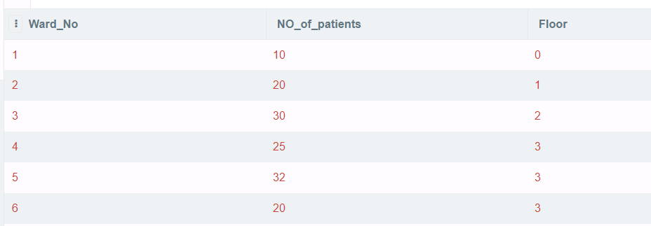

Patient Table

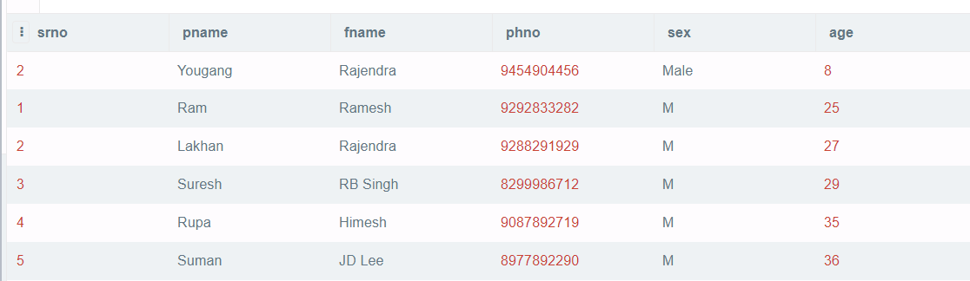

Doctors Table

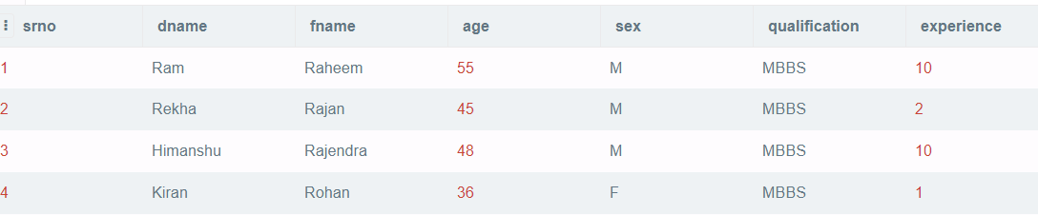

**Program code**

from tkinter import *

import sqlite3 as sql

import matplotlib.pyplot as plt

import pandas as pd

import tkinter.messagebox as tmsg

from PIL import ImageTk,Image

conn=sql.connect("project.db")

c=conn.cursor()

conn2=sql.connect("project2.db")

c0=conn2.cursor()

root=Tk()

root.geometry("900x900")

root.minsize(900,900)

root.maxsize(900,900)

f1=Frame(root,bg="blue")

f2=Frame(root,bg="green")

f1.pack(side=TOP,fill=X)

f2.pack(side=TOP,fill=X)

##################################################

def getvalsm():

rootra9=Toplevel()

rootra9.geometry("1540x900")

rootra9.title("Hospital Management 'hellow user'")

fz0009=Frame(rootra9,bg="blue")

imagec =Image.open('ppp.jpg')

imager = ImageTk.PhotoImage(imagec)

a=Label(fz0009,text="Topic : HOSPITAL MANAGEMENT",bg="red",fg="white",font="sansns 30 bold italic underline",borderwidth=5,relief=SUNKEN,padx=10)

a.pack(pady=5)

Button(fz0009,image=imager,command=umar,bg="red",fg="white",font="lucida",height=650,width=1350,borderwidth=5,relief=SUNKEN,padx=10,pady=5).pack(pady=10)

fz0009.pack(fill=X)

Button(fz0009,text="end",bg="red",fg="white",font="sansns 50 bold",borderwidth=5,relief=SUNKEN,padx=10,pady=5).pack(pady=350)

fz0009.pack(fill=X)

ooo=Frame(rootra9,bg="blue")

Button(fz0009,text="end",bg="red",fg="white",font="sansns 50 bold",borderwidth=5,relief=SUNKEN,padx=10,pady=5).pack(pady=350)

fz0009.pack(fill=X)

ooo.pack()

rootra9.mainloop()

#######################################################

def umar():

if userentry.get()=="rajat" and passentry.get()=="rkkr":

print("Welcome to our software of hospital manaagement")

root2=Toplevel()

root2.geometry("1530x900")

root2.minsize(1530,900)

root2.title("Main Menu")

f1=Frame(root2,bg="blue",padx=5)

a1=Label(f1,text="Topic : Hospital Mangement",bg="red",fg="white",font="sunsns 30 bold",borderwidth=10,relief=SUNKEN)

a2=Label(f1,text="Main Menu",bg="red",fg="white",font="sunsns 30 bold",borderwidth=10,relief=SUNKEN)

def pg1():

root1 = Toplevel()

root1.title("top window")

root1.geometry("1570x900")

def pp_1():

with conn:

try:

c.execute("select * from Ward25")

a1=p_1.get()

a2=p_2.get()

a3=p_3.get()

c.execute(f"insert into Ward25(Ward_No,NO_of_patients,Floor) values(?,?,?)",(a1,a2,a3))

conn.commit()

except:

c.execute("create table Ward25(Ward_No int primary key,NO_of_patients int,Floor int);")

a1=p_1.get()

a2=p_2.get()

a3=p_3.get()

c.execute(f"insert into Ward25(Ward_No,NO_of_patients,Floor) values(?,?,?)",(a1,a2,a3))

conn.commit()

def pp_2():

with conn2:

try:

c0.execute("select * from patient3")

a4=p_4.get()

a5=p_5.get()

a6=p_6.get()

a7=p_7.get()

a8=p_8.get()

a9=p_9.get()

c0.execute(f"insert into patient3(srno, pname, fname, phno, sex, age) values(?,?,?,?,?,?)",(a4,a5,a6,a7,a8,a9))

conn2.commit()

c0.execute("select * from patient3")

print(c0.fetchall())

except:

c0.execute("create table patient3(srno int,pname varchar(50),fname varchar(50),phno int,sex varchar(50),age int);")

a4=p_4.get()

a5=p_5.get()

a6=p_6.get()

a7=p_7.get()

a8=p_8.get()

a9=p_9.get()

c0.execute(f"insert into patient3(srno, pname, fname, phno, sex, age) values(?,?,?,?,?,?)",(a4,a5,a6,a7,a8,a9))

conn2.commit()

c0.execute("select * from patient3")

conn2.commit()

print(c0.fetchall())

def pp_3():

with conn:

try:

c.execute("select * from doctors")

a10=p_10.get()

a11=p_11.get()

a12=p_12.get()

a13=p_13.get()

a14=p_14.get()

a15=p_15.get()

a16=p_16.get()

c.execute(f"insert into doctors(srno,dname,fname,age,sex,qualification,experience) values(?,?,?,?,?,?,?)",(a10,a11,a12,a13,a14,a15,a16))

conn.commit()

except:

c.execute("create table doctors(srno int primary key,dname varchar(50),fname varchar(50),age int,sex varchar(50),qualification varchar(50),experience int);")

a10=p_10.get()

a11=p_11.get()

a12=p_12.get()

a13=p_13.get()

a14=p_14.get()

a15=p_15.get()

a16=p_16.get()

c.execute(f"insert into doctors(srno,dname,fname,age,sex,qualification,experience) values(?,?,?,?,?,?,?)",(a10,a11,a12,a13,a14,a15,a16))

conn.commit()

f1=Frame(root1,bg="blue")

Label(f1,text="Add New Record",bg="red",fg="white",font="sansns 20 bold",borderwidth=5,relief=SUNKEN,padx=10).pack(fill=X,pady=6)

f1.pack(side=TOP,fill=X)

f2=Frame(root1,bg="blue")

Label(f2,text="New Ward",bg="grey",fg="black",font="sansns 16 bold",borderwidth=5,relief=SUNKEN,padx=10).pack(side=LEFT,anchor="w",pady=6)

f2.pack(side=TOP,fill=X)

f3=Frame(root1,bg="blue")

Label(f3,text="Ward No.",bg="grey",fg="black",width=12,font="sansns 14 bold",borderwidth=5,relief=SUNKEN,padx=10).pack(side=LEFT)

Label(f3,text="No. of Patient",bg="grey",fg="black",width=12,font="sansns 14 bold",borderwidth=5,relief=SUNKEN,padx=10).pack(side=LEFT)

Label(f3,text="Floor",bg="grey",fg="black",width=12,font="sansns 14 bold",borderwidth=5,relief=SUNKEN,padx=10).pack(side=LEFT)

f3.pack(fill=X)

f4=Frame(root1,bg="blue")

p_1=IntVar()

p_2=IntVar()

p_3=IntVar()

Entry(f4,textvariable=p_1,bg="white",fg="black",width=15,font="sansns 14 bold",borderwidth=5,relief=SUNKEN).pack(side=LEFT)

Entry(f4,textvariable=p_2,bg="white",fg="black",width=14,font="sansns 14 bold",borderwidth=5,relief=SUNKEN).pack(side=LEFT)

Entry(f4,textvariable=p_3,bg="white",fg="black",width=15,font="sansns 14 bold",borderwidth=5,relief=SUNKEN).pack(side=LEFT)

f4.pack(fill=X)

f5=Frame(root1,bg="blue")

Button(f5,text="---Add Now",command=pp_1,bg="red",fg="white",font="sansns 20 bold",borderwidth=5,relief=SUNKEN,padx=10).pack(pady=6,side=RIGHT)

f5.pack(fill=X)

f6=Frame(root1,bg="blue")

Label(f6,text="New Patient",bg="grey",fg="black",font="sansns 16 bold",borderwidth=5,relief=SUNKEN,padx=10).pack(side=LEFT,anchor="w",pady=6)

f6.pack(fill=X)

f7=Frame(root1,bg="blue")

Label(f7,text="Sr No.",bg="grey",fg="black",width=13,font="sansns 14 bold",borderwidth=5,relief=SUNKEN,padx=10).pack(side=LEFT)

Label(f7,text="PName",bg="grey",fg="black",width=13,font="sansns 14 bold",borderwidth=5,relief=SUNKEN,padx=10).pack(side=LEFT)

Label(f7,text="FName",bg="grey",fg="black",width=13,font="sansns 14 bold",borderwidth=5,relief=SUNKEN,padx=10).pack(side=LEFT)

Label(f7,text="Ph.No.",bg="grey",fg="black",width=14,font="sansns 14 bold",borderwidth=5,relief=SUNKEN,padx=10).pack(side=LEFT)

Label(f7,text="Sex",bg="grey",fg="black",width=13,font="sansns 14 bold",borderwidth=5,relief=SUNKEN,padx=10).pack(side=LEFT)

Label(f7,text="Age",bg="grey",fg="black",width=13,font="sansns 14 bold",borderwidth=5,relief=SUNKEN,padx=10).pack(side=LEFT)

f7.pack(fill=X)

f8=Frame(root1,bg="blue")

p_4=IntVar()

p_5=StringVar()

p_6=StringVar()

p_7=IntVar()

p_8=StringVar()

p_9=IntVar()

Entry(f8,textvariable=p_4,bg="white",fg="black",width=16,font="sansns 14 bold",borderwidth=5,relief=SUNKEN).pack(side=LEFT)

Entry(f8,textvariable=p_5,bg="white",fg="black",width=16,font="sansns 14 bold",borderwidth=5,relief=SUNKEN).pack(side=LEFT)

Entry(f8,textvariable=p_6,bg="white",fg="black",width=16,font="sansns 14 bold",borderwidth=5,relief=SUNKEN).pack(side=LEFT)

Entry(f8,textvariable=p_7,bg="white",fg="black",width=16,font="sansns 14 bold",borderwidth=5,relief=SUNKEN).pack(side=LEFT)

Entry(f8,textvariable=p_8,bg="white",fg="black",width=16,font="sansns 14 bold",borderwidth=5,relief=SUNKEN).pack(side=LEFT)

Entry(f8,textvariable=p_9,bg="white",fg="black",width=16,font="sansns 14 bold",borderwidth=5,relief=SUNKEN).pack(side=LEFT)

f8.pack(fill=X)

f9=Frame(root1,bg="blue")

Button(f9,text="---Add Now",command=pp_2,bg="red",fg="white",font="sansns 20 bold",borderwidth=5,relief=SUNKEN,padx=10).pack(pady=6,side=RIGHT)

f9.pack(fill=X)

f10=Frame(root1,bg="blue")

Label(f10,text="New Doctor",bg="grey",fg="black",font="sansns 16 bold",borderwidth=5,relief=SUNKEN,padx=10).pack(pady=6,side=LEFT,anchor="w")

f10.pack(fill=X)

f11=Frame(root1,bg="blue")

Label(f11,text="Sr No.",bg="grey",fg="black",width=13,font="sansns 14 bold",borderwidth=5,relief=SUNKEN,padx=10).pack(side=LEFT)

Label(f11,text="DName",bg="grey",fg="black",width=13,font="sansns 14 bold",borderwidth=5,relief=SUNKEN,padx=10).pack(side=LEFT)

Label(f11,text="FName",bg="grey",fg="black",width=13,font="sansns 14 bold",borderwidth=5,relief=SUNKEN,padx=10).pack(side=LEFT)

Label(f11,text="Age",bg="grey",fg="black",width=14,font="sansns 14 bold",borderwidth=5,relief=SUNKEN,padx=10).pack(side=LEFT)

Label(f11,text="Sex",bg="grey",fg="black",width=13,font="sansns 14 bold",borderwidth=5,relief=SUNKEN,padx=10).pack(side=LEFT)

Label(f11,text="Qualification",bg="grey",fg="black",width=13,font="sansns 14 bold",borderwidth=5,relief=SUNKEN,padx=10).pack(side=LEFT)

Label(f11,text="Experience(yr)",bg="grey",fg="black",width=13,font="sansns 14 bold",borderwidth=5,relief=SUNKEN,padx=10).pack(side=LEFT)

f11.pack(fill=X)

f12=Frame(root1,bg="blue")

p_10=IntVar()

p_11=StringVar()

p_12=StringVar()

p_13=IntVar()

p_14=StringVar()

p_15=StringVar()

p_16=IntVar()

Entry(f12,textvariable=p_10,bg="white",fg="black",width=16,font="sansns 14 bold",borderwidth=5,relief=SUNKEN).pack(side=LEFT)

Entry(f12,textvariable=p_11,bg="white",fg="black",width=16,font="sansns 14 bold",borderwidth=5,relief=SUNKEN).pack(side=LEFT)

Entry(f12,textvariable=p_12,bg="white",fg="black",width=16,font="sansns 14 bold",borderwidth=5,relief=SUNKEN).pack(side=LEFT)

Entry(f12,textvariable=p_13,bg="white",fg="black",width=16,font="sansns 14 bold",borderwidth=5,relief=SUNKEN).pack(side=LEFT)

Entry(f12,textvariable=p_14,bg="white",fg="black",width=16,font="sansns 14 bold",borderwidth=5,relief=SUNKEN).pack(side=LEFT)

Entry(f12,textvariable=p_15,bg="white",fg="black",width=16,font="sansns 14 bold",borderwidth=5,relief=SUNKEN).pack(side=LEFT)

Entry(f12,textvariable=p_16,bg="white",fg="black",width=16,font="sansns 14 bold",borderwidth=5,relief=SUNKEN).pack(side=LEFT)

f12.pack(fill=X)

f13=Frame(root1,bg="blue")

Button(f13,text="---Add Now",command=pp_3,bg="red",fg="white",font="sansns 20 bold",borderwidth=5,relief=SUNKEN,padx=10).pack(pady=6,side=RIGHT)

f13.pack(fill=X)

f14=Frame(root1,bg="blue")

Button(f14,text="Click to go to previous page",command=root1.destroy,bg="red",fg="white",font="sansns 20 bold",borderwidth=5,relief=SUNKEN,padx=10).pack(pady=60)

f14.pack(fill=X)

def pg2():

rootp2 = Toplevel()

rootp2.title("Update Records ---P2")

rootp2.geometry("1600x900")

def p2_r():

conn=sql.connect("project.db")

c=conn.cursor()

with conn:

z1=p22_1.get()

z2=p22_2.get()

z3=p22_3.get()

c.execute(f"update Ward25 set Ward_No={z1},NO_of_patients={z2},Floor={z3} where Ward_No={z1}")

conn.commit()

c.execute("select * from Ward25")

c.fetchall()

def p2_2():

conn2=sql.connect("project2.db")

c0=conn0.cursor()

with conn2:

z4=p22_4.get()

z5=p22_5.get()

z6=p22_6.get()

z7=p22_7.get()

z8=p22_8.get()

z9=p22_9.get()

c0.execute(f"update patient3 set srno={z4},pname={z5},fname={z6},phno={z7},sex={z8},age={z9} where srno={z4}")

conn2.commit()

c0.execute("select * from patient3")

c0.fetchall()

def p2_3():

conn=sql.connect("project.db")

c=conn.cursor()

with conn:

z10=p22_10.get()

z11=p22_11.get()

z12=p22_12.get()

z13=p22_13.get()

z14=p22_14.get()

z15=p22_15.get()

c.execute(f"update doctors set srno={z10},dname={z11},fname={z12},age={z13},sex={z14},qualification={z15},experience={z16} where srno={z10}")

conn.commit()

c.execute("select * from doctors")

c.fetchall()

f1=Frame(rootp2,bg="blue")

Label(f1,text="Update Records",bg="red",fg="white",font="sansns 20 bold",borderwidth=5,relief=SUNKEN,padx=10).pack(fill=X,pady=6)

f1.pack(side=TOP,fill=X)

f2=Frame(rootp2,bg="blue")

Label(f2,text="Update Ward",bg="grey",fg="black",font="sansns 16 bold",borderwidth=5,relief=SUNKEN,padx=10).pack(side=LEFT,anchor="w",pady=6)

f2.pack(side=TOP,fill=X)

f3=Frame(rootp2,bg="blue")

Label(f3,text="Ward No.",bg="grey",fg="black",width=12,font="sansns 14 bold",borderwidth=5,relief=SUNKEN,padx=10).pack(side=LEFT)

Label(f3,text="No. of Patient",bg="grey",fg="black",width=12,font="sansns 14 bold",borderwidth=5,relief=SUNKEN,padx=10).pack(side=LEFT)

Label(f3,text="Floor",bg="grey",fg="black",width=12,font="sansns 14 bold",borderwidth=5,relief=SUNKEN,padx=10).pack(side=LEFT)

f3.pack(fill=X)

f4=Frame(rootp2,bg="blue")

p22_1=IntVar()

p22_2=IntVar()

p22_3=IntVar()

Entry(f4,textvariable=p22_1,bg="white",fg="black",width=15,font="sansns 14 bold",borderwidth=5,relief=SUNKEN).pack(side=LEFT)

Entry(f4,textvariable=p22_2,bg="white",fg="black",width=14,font="sansns 14 bold",borderwidth=5,relief=SUNKEN).pack(side=LEFT)

Entry(f4,textvariable=p22_3,bg="white",fg="black",width=15,font="sansns 14 bold",borderwidth=5,relief=SUNKEN).pack(side=LEFT)

f4.pack(fill=X)

f5=Frame(rootp2,bg="blue")

Button(f5,text="---Update Now",command=p2_r,bg="red",fg="white",font="sansns 20 bold",borderwidth=5,relief=SUNKEN,padx=10).pack(pady=6,side=RIGHT)

f5.pack(fill=X)

f6=Frame(rootp2,bg="blue")

Label(f6,text="Update Patient",bg="grey",fg="black",font="sansns 16 bold",borderwidth=5,relief=SUNKEN,padx=10).pack(side=LEFT,anchor="w",pady=6)

f6.pack(fill=X)

f7=Frame(rootp2,bg="blue")

Label(f7,text="Sr No.",bg="grey",fg="black",width=13,font="sansns 14 bold",borderwidth=5,relief=SUNKEN,padx=10).pack(side=LEFT)

Label(f7,text="PName",bg="grey",fg="black",width=13,font="sansns 14 bold",borderwidth=5,relief=SUNKEN,padx=10).pack(side=LEFT)

Label(f7,text="FName",bg="grey",fg="black",width=13,font="sansns 14 bold",borderwidth=5,relief=SUNKEN,padx=10).pack(side=LEFT)

Label(f7,text="Ph.No.",bg="grey",fg="black",width=14,font="sansns 14 bold",borderwidth=5,relief=SUNKEN,padx=10).pack(side=LEFT)

Label(f7,text="Sex",bg="grey",fg="black",width=13,font="sansns 14 bold",borderwidth=5,relief=SUNKEN,padx=10).pack(side=LEFT)

Label(f7,text="Age",bg="grey",fg="black",width=13,font="sansns 14 bold",borderwidth=5,relief=SUNKEN,padx=10).pack(side=LEFT)

f7.pack(fill=X)

f8=Frame(rootp2,bg="blue")

p22_4=IntVar()

p22_5=StringVar()

p22_6=StringVar()

p22_7=IntVar()

p22_8=StringVar()

p22_9=IntVar()

Entry(f8,textvariable=p22_4,bg="white",fg="black",width=16,font="sansns 14 bold",borderwidth=5,relief=SUNKEN).pack(side=LEFT)

Entry(f8,textvariable=p22_5,bg="white",fg="black",width=16,font="sansns 14 bold",borderwidth=5,relief=SUNKEN).pack(side=LEFT)

Entry(f8,textvariable=p22_6,bg="white",fg="black",width=16,font="sansns 14 bold",borderwidth=5,relief=SUNKEN).pack(side=LEFT)

Entry(f8,textvariable=p22_7,bg="white",fg="black",width=16,font="sansns 14 bold",borderwidth=5,relief=SUNKEN).pack(side=LEFT)

Entry(f8,textvariable=p22_8,bg="white",fg="black",width=16,font="sansns 14 bold",borderwidth=5,relief=SUNKEN).pack(side=LEFT)

Entry(f8,textvariable=p22_9,bg="white",fg="black",width=16,font="sansns 14 bold",borderwidth=5,relief=SUNKEN).pack(side=LEFT)

f8.pack(fill=X)

f9=Frame(rootp2,bg="blue")

Button(f9,text="---Update Now",command=p2_2,bg="red",fg="white",font="sansns 20 bold",borderwidth=5,relief=SUNKEN,padx=10).pack(pady=6,side=RIGHT)

f9.pack(fill=X)

f10=Frame(rootp2,bg="blue")

Label(f10,text="Update Doctor",bg="grey",fg="black",font="sansns 16 bold",borderwidth=5,relief=SUNKEN,padx=10).pack(pady=6,side=LEFT,anchor="w")

f10.pack(fill=X)

f11=Frame(rootp2,bg="blue")

Label(f11,text="Sr No.",bg="grey",fg="black",width=13,font="sansns 14 bold",borderwidth=5,relief=SUNKEN,padx=10).pack(side=LEFT)

Label(f11,text="DName",bg="grey",fg="black",width=13,font="sansns 14 bold",borderwidth=5,relief=SUNKEN,padx=10).pack(side=LEFT)

Label(f11,text="FName",bg="grey",fg="black",width=13,font="sansns 14 bold",borderwidth=5,relief=SUNKEN,padx=10).pack(side=LEFT)

Label(f11,text="Age",bg="grey",fg="black",width=14,font="sansns 14 bold",borderwidth=5,relief=SUNKEN,padx=10).pack(side=LEFT)

Label(f11,text="Sex",bg="grey",fg="black",width=13,font="sansns 14 bold",borderwidth=5,relief=SUNKEN,padx=10).pack(side=LEFT)

Label(f11,text="Qualification",bg="grey",fg="black",width=13,font="sansns 14 bold",borderwidth=5,relief=SUNKEN,padx=10).pack(side=LEFT)

Label(f11,text="Experience(yr)",bg="grey",fg="black",width=13,font="sansns 14 bold",borderwidth=5,relief=SUNKEN,padx=10).pack(side=LEFT)

f11.pack(fill=X)

f12=Frame(rootp2,bg="blue")

p22_10=IntVar()

p22_11=StringVar()

p22_12=StringVar()

p22_13=IntVar()

p22_14=StringVar()

p22_15=StringVar()

p22_16=IntVar()

Entry(f12,textvariable=p22_10,bg="white",fg="black",width=16,font="sansns 14 bold",borderwidth=5,relief=SUNKEN).pack(side=LEFT)

Entry(f12,textvariable=p22_11,bg="white",fg="black",width=16,font="sansns 14 bold",borderwidth=5,relief=SUNKEN).pack(side=LEFT)

Entry(f12,textvariable=p22_12,bg="white",fg="black",width=16,font="sansns 14 bold",borderwidth=5,relief=SUNKEN).pack(side=LEFT)

Entry(f12,textvariable=p22_13,bg="white",fg="black",width=16,font="sansns 14 bold",borderwidth=5,relief=SUNKEN).pack(side=LEFT)

Entry(f12,textvariable=p22_14,bg="white",fg="black",width=16,font="sansns 14 bold",borderwidth=5,relief=SUNKEN).pack(side=LEFT)

Entry(f12,textvariable=p22_15,bg="white",fg="black",width=16,font="sansns 14 bold",borderwidth=5,relief=SUNKEN).pack(side=LEFT)

Entry(f12,textvariable=p22_16,bg="white",fg="black",width=16,font="sansns 14 bold",borderwidth=5,relief=SUNKEN).pack(side=LEFT)

f12.pack(fill=X)

f13=Frame(rootp2,bg="blue")

Button(f13,text="---Update Now",command=p2_3,bg="red",fg="white",font="sansns 20 bold",borderwidth=5,relief=SUNKEN,padx=10).pack(pady=6,side=RIGHT)

f13.pack(fill=X)

f14=Frame(rootp2,bg="blue")

Button(f14,text="Click to go to previous page",command=rootp2.destroy,bg="red",fg="white",font="sansns 20 bold",borderwidth=5,relief=SUNKEN,padx=10).pack(pady=60)

f14.pack(fill=X)

rootp2.mainloop()

def pg3():

rootp3 = Toplevel()

rootp3.title("Delete Records ---P2")

rootp3.geometry("1570x900")

def p3_1():

conn=sql.connect("project.db")

c=conn.cursor()

with conn:

y1=pr3_1.get()

y2=pr3_2.get()

y3=pr3_3.get()

c.execute(f"delete from Ward25 where Ward_No={y1} and NO_of_patients={y2}")

conn.commit()

c.execute("select * from Ward25")

c.fetchall()

def p3_2():

conn2=sql.connect("project2.db")

c0=conn2.cursor()

with conn2:

y4=pr3_4.get()

y5=pr3_5.get()

y6=pr3_6.get()

y7=pr3_7.get()

y8=pr3_8.get()

y9=pr3_9.get()

c0.execute(f"delete from patient3 where srno={y4} and pname={y5}")

conn2.commit()

c0.execute("select * from patient3")

c0.fetchall()

def p3_3():

conn=sql.connect("project.db")

c=conn.cursor()

with conn:

y10=pr3_10.get()

y11=pr3_11.get()

y12=pr3_12.get()

c.execute(f"delete from doctors where srno={y10} and dname={y11}")

conn.commit()

c.execute("select * from doctors")

c.fetchall()

f1=Frame(rootp3,bg="blue")

Label(f1,text="Delete Records",bg="red",fg="white",font="sansns 20 bold",borderwidth=5,relief=SUNKEN,padx=10).pack(fill=X,pady=6)

f1.pack(side=TOP,fill=X)

f2=Frame(rootp3,bg="blue")

Label(f2,text="Delete Ward",bg="grey",fg="black",font="sansns 16 bold",borderwidth=5,relief=SUNKEN,padx=10).pack(side=LEFT,anchor="w",pady=6)

f2.pack(side=TOP,fill=X)

f3=Frame(rootp3,bg="blue")

Label(f3,text="Ward No.",bg="grey",fg="black",width=12,font="sansns 14 bold",borderwidth=5,relief=SUNKEN,padx=10).pack(side=LEFT)

Label(f3,text="No. of Patient",bg="grey",fg="black",width=12,font="sansns 14 bold",borderwidth=5,relief=SUNKEN,padx=10).pack(side=LEFT)

Label(f3,text="Floor",bg="grey",fg="black",width=12,font="sansns 14 bold",borderwidth=5,relief=SUNKEN,padx=10).pack(side=LEFT)

f3.pack(fill=X)

f4=Frame(rootp3,bg="blue")

pr3_1=IntVar()

pr3_2=IntVar()

pr3_3=IntVar()

Entry(f4,textvariable=pr3_1,bg="white",fg="black",width=15,font="sansns 14 bold",borderwidth=5,relief=SUNKEN).pack(side=LEFT)

Entry(f4,textvariable=pr3_2,bg="white",fg="black",width=14,font="sansns 14 bold",borderwidth=5,relief=SUNKEN).pack(side=LEFT)

Entry(f4,textvariable=pr3_3,bg="white",fg="black",width=15,font="sansns 14 bold",borderwidth=5,relief=SUNKEN).pack(side=LEFT)

f4.pack(fill=X)

f5=Frame(rootp3,bg="blue")

Button(f5,text="---Delete Now",command=p3_1,bg="red",fg="white",font="sansns 20 bold",borderwidth=5,relief=SUNKEN,padx=10).pack(pady=6,side=RIGHT)

f5.pack(fill=X)

f6=Frame(rootp3,bg="blue")

Label(f6,text="Delete Patient",bg="grey",fg="black",font="sansns 16 bold",borderwidth=5,relief=SUNKEN,padx=10).pack(side=LEFT,anchor="w",pady=6)

f6.pack(fill=X)

f7=Frame(rootp3,bg="blue")

Label(f7,text="Sr No.",bg="grey",fg="black",width=13,font="sansns 14 bold",borderwidth=5,relief=SUNKEN,padx=10).pack(side=LEFT)

Label(f7,text="PName",bg="grey",fg="black",width=13,font="sansns 14 bold",borderwidth=5,relief=SUNKEN,padx=10).pack(side=LEFT)

Label(f7,text="FName",bg="grey",fg="black",width=13,font="sansns 14 bold",borderwidth=5,relief=SUNKEN,padx=10).pack(side=LEFT)

Label(f7,text="Ph.No.",bg="grey",fg="black",width=14,font="sansns 14 bold",borderwidth=5,relief=SUNKEN,padx=10).pack(side=LEFT)

Label(f7,text="Sex",bg="grey",fg="black",width=13,font="sansns 14 bold",borderwidth=5,relief=SUNKEN,padx=10).pack(side=LEFT)

Label(f7,text="Age",bg="grey",fg="black",width=13,font="sansns 14 bold",borderwidth=5,relief=SUNKEN,padx=10).pack(side=LEFT)

f7.pack(fill=X)

f8=Frame(rootp3,bg="blue")

pr3_4=IntVar()

pr3_5=StringVar()

pr3_6=StringVar()

pr3_7=IntVar()

pr3_8=StringVar()

pr3_9=IntVar()

Entry(f8,textvariable=pr3_4,bg="white",fg="black",width=16,font="sansns 14 bold",borderwidth=5,relief=SUNKEN).pack(side=LEFT)

Entry(f8,textvariable=pr3_5,bg="white",fg="black",width=16,font="sansns 14 bold",borderwidth=5,relief=SUNKEN).pack(side=LEFT)

Entry(f8,textvariable=pr3_6,bg="white",fg="black",width=16,font="sansns 14 bold",borderwidth=5,relief=SUNKEN).pack(side=LEFT)

Entry(f8,textvariable=pr3_7,bg="white",fg="black",width=16,font="sansns 14 bold",borderwidth=5,relief=SUNKEN).pack(side=LEFT)

Entry(f8,textvariable=pr3_8,bg="white",fg="black",width=16,font="sansns 14 bold",borderwidth=5,relief=SUNKEN).pack(side=LEFT)

Entry(f8,textvariable=pr3_9,bg="white",fg="black",width=16,font="sansns 14 bold",borderwidth=5,relief=SUNKEN).pack(side=LEFT)

f8.pack(fill=X)

f9=Frame(rootp3,bg="blue")

Button(f9,text="---Delete Now",command=p3_2,bg="red",fg="white",font="sansns 20 bold",borderwidth=5,relief=SUNKEN,padx=10).pack(pady=6,side=RIGHT)

f9.pack(fill=X)

f10=Frame(rootp3,bg="blue")

Label(f10,text="Delete Doctor",bg="grey",fg="black",font="sansns 16 bold",borderwidth=5,relief=SUNKEN,padx=10).pack(pady=6,side=LEFT,anchor="w")

f10.pack(fill=X)

f11=Frame(rootp3,bg="blue")

Label(f11,text="Sr No.",bg="grey",fg="black",width=13,font="sansns 14 bold",borderwidth=5,relief=SUNKEN,padx=10).pack(side=LEFT)

Label(f11,text="DName",bg="grey",fg="black",width=13,font="sansns 14 bold",borderwidth=5,relief=SUNKEN,padx=10).pack(side=LEFT)

Label(f11,text="FName",bg="grey",fg="black",width=13,font="sansns 14 bold",borderwidth=5,relief=SUNKEN,padx=10).pack(side=LEFT)

Label(f11,text="Age",bg="grey",fg="black",width=14,font="sansns 14 bold",borderwidth=5,relief=SUNKEN,padx=10).pack(side=LEFT)

Label(f11,text="Sex",bg="grey",fg="black",width=13,font="sansns 14 bold",borderwidth=5,relief=SUNKEN,padx=10).pack(side=LEFT)

Label(f11,text="Qualification",bg="grey",fg="black",width=13,font="sansns 14 bold",borderwidth=5,relief=SUNKEN,padx=10).pack(side=LEFT)

Label(f11,text="Experience(yr)",bg="grey",fg="black",width=13,font="sansns 14 bold",borderwidth=5,relief=SUNKEN,padx=10).pack(side=LEFT)

f11.pack(fill=X)

f12=Frame(rootp3,bg="blue")

pr3_10=IntVar()

pr3_11=StringVar()

pr3_12=StringVar()

pr3_13=IntVar()

pr3_14=StringVar()

pr3_15=StringVar()

pr3_16=IntVar()

Entry(f12,textvariable=pr3_10,bg="white",fg="black",width=16,font="sansns 14 bold",borderwidth=5,relief=SUNKEN).pack(side=LEFT)

Entry(f12,textvariable=pr3_11,bg="white",fg="black",width=16,font="sansns 14 bold",borderwidth=5,relief=SUNKEN).pack(side=LEFT)

Entry(f12,textvariable=pr3_12,bg="white",fg="black",width=16,font="sansns 14 bold",borderwidth=5,relief=SUNKEN).pack(side=LEFT)

Entry(f12,textvariable=pr3_13,bg="white",fg="black",width=16,font="sansns 14 bold",borderwidth=5,relief=SUNKEN).pack(side=LEFT)

Entry(f12,textvariable=pr3_14,bg="white",fg="black",width=16,font="sansns 14 bold",borderwidth=5,relief=SUNKEN).pack(side=LEFT)

Entry(f12,textvariable=pr3_15,bg="white",fg="black",width=16,font="sansns 14 bold",borderwidth=5,relief=SUNKEN).pack(side=LEFT)

Entry(f12,textvariable=pr3_16,bg="white",fg="black",width=16,font="sansns 14 bold",borderwidth=5,relief=SUNKEN).pack(side=LEFT)

f12.pack(fill=X)

f13=Frame(rootp3,bg="blue")

Button(f13,text="---Delete Now",command=p3_3,bg="red",fg="white",font="sansns 20 bold",borderwidth=5,relief=SUNKEN,padx=10).pack(pady=6,side=RIGHT)

f13.pack(fill=X)

f14=Frame(rootp3,bg="blue")

Button(f14,text="Click to go to previous page",command=rootp3.destroy,bg="red",fg="white",font="sansns 20 bold",borderwidth=5,relief=SUNKEN,padx=10).pack(pady=60)

f14.pack(fill=X)

rootp3.mainloop()

def pg4():

rootp4 = Toplevel()

rootp4.geometry("1530x900")

rootp4.minsize(1530,900)

rootp4.title("Display Records---P4")

f4_1=Frame(rootp4,bg="blue",padx=5)

a2=Label(f4_1,text="Display",bg="red",fg="white",font="sunsns 30 bold",borderwidth=10,relief=SUNKEN)

def pg1():

with conn:

c.execute("select * from Ward25")

df=c.fetchall()

df1=pd.DataFrame(df,columns=["Ward No.","No of Patients","Floor"])

rootra=Tk()

rootra.geometry("1540x900")

rootra.title("Display WARD TABLE..................%")

f0001=Frame(rootra,bg="blue")

a=Label(f0001,text="-----------------WARD TABLE----------------",bg="red",fg="white",font="sansns 30 bold",borderwidth=5,relief=SUNKEN,padx=10)

a.pack(pady=5)

Button(f0001,text=f"{df1.to_string(index=False)}",command=rootra.destroy,bg="red",fg="white",font="lucida 20 bold",borderwidth=5,relief=SUNKEN,padx=10,pady=5).pack(pady=10)

f0001.pack(fill=X)

Button(f0001,text="end",bg="red",fg="white",font="sansns 50 bold",borderwidth=5,relief=SUNKEN,padx=10,pady=5).pack(pady=350)

f0001.pack(fill=X)

rootra.mainloop()

def pg2():

with conn2:

c0.execute("select * from patient3")

dfr=c0.fetchall()

dfr1=pd.DataFrame(dfr,columns=["Srno","FName","PName","Ph_No","Sex","Age"])

rootrra=Tk()

rootrra.geometry("1540x900")

rootrra.title("Display PATIENT TABLE..................%")

f00001=Frame(rootrra,bg="blue")

a=Label(f00001,text="-----------------PATIENT TABLE----------------",bg="red",fg="white",font="sansns 30 bold",borderwidth=5,relief=SUNKEN,padx=10)

a.pack(pady=5)

Button(f00001,text=f"{dfr1.to_string(index=False)}",command=rootrra.destroy,bg="red",fg="white",font="lucida 20 bold",borderwidth=5,relief=SUNKEN,padx=10,pady=5).pack(pady=10)

f00001.pack(fill=X)

gamma=Button(f00001,text="end",bg="red",fg="white",font="sansns 50 bold",borderwidth=5,relief=SUNKEN,padx=10,pady=5)

gamma.pack(pady=350)

f00001.pack(fill=X)

rootrra.mainloop()

def pg3():

with conn:

c.execute("select * from doctors")

dfz=c.fetchall()

dfz1=pd.DataFrame(dfz,columns=["srnn","dname","fname","age","sex","qualification","experience"])

rootra2=Tk()

rootra2.geometry("1540x900")

rootra2.title("Display DOCTORS TABLE..................%")

fz0001=Frame(rootra2,bg="blue")

a=Label(fz0001,text="-----------------DOCTORS TABLE----------------",bg="red",fg="white",font="sansns 30 bold",borderwidth=5,relief=SUNKEN,padx=10)

a.pack(pady=5)

Button(fz0001,text=f"{dfz1.to_string(index=False)}",command=rootra2.destroy,bg="red",fg="white",font="lucida 20 bold",borderwidth=5,relief=SUNKEN,padx=10,pady=5).pack(pady=10)

fz0001.pack(fill=X)

Button(fz0001,text="end",bg="red",fg="white",font="sansns 50 bold",borderwidth=5,relief=SUNKEN,padx=10,pady=5).pack(pady=350)

fz0001.pack(fill=X)

rootra2.mainloop()

b1=Button(f4_1,text="1.Ward Records",command=pg1,bg="grey",fg="black",font="lucida 20 bold",borderwidth=10,relief=SUNKEN,padx=10,pady=15)

b2=Button(f4_1,text="2.Patient Records",command=pg2,bg="grey",fg="black",font="lucida 20 bold",borderwidth=10,relief=SUNKEN,padx=20,pady=15)

b3=Button(f4_1,text="3.Doctor RecordS",command=pg3,bg="grey",fg="black",font="lucida 20 bold",borderwidth=10,relief=SUNKEN,padx=25,pady=15)

f4_1.pack(side=TOP,fill=X)

a2.pack(side=TOP,pady=5,fill=X)

b1.pack(side=TOP,anchor="nw",pady=15)

b2.pack(side=TOP,anchor="nw",pady=15)

b3.pack(side=TOP,anchor="nw",pady=15)

f4_2=Frame(rootp4,bg="blue")

Button(f4_2,text="Click to go to previous page",command=rootp4.destroy,bg="red",fg="white",font="sansns 20 bold",borderwidth=5,relief=SUNKEN,padx=10).pack(pady=170,side=BOTTOM)

f4_2.pack(fill=X)

rootp4.mainloop()

def pg5():

rootp5 = Toplevel()

rootp5.title("Statistics----P5")

rootp5.geometry("1570x900")

def p55_1():

conn=sql.connect("project.db")

c=conn.cursor()

with conn:

c.execute("select * from Ward25")

df2=c.fetchall()

df2=pd.DataFrame(df2,columns=["Ward No","No of Patients",". |Floor"])

df2.plot.bar(x="Ward No",y="No of Patients",rot=0,title="BAR GRAPH",xlabel="Ward No",ylabel="No of Patients",color="red")

plt.show()

def p55_2():

conn=sql.connect("project.db")

c=conn.cursor()

with conn:

c.execute("select * from Ward25")

df2=c.fetchall()

df2=pd.DataFrame(df2,columns=["Ward No","No of Patients",". |Floor"])

df2.plot.pie(x="Ward No",y="No of Patients",title="BAR GRAPH")

plt.show()

def p55_3():

conn=sql.connect("project.db")

c=conn.cursor()

with conn:

c.execute("select * from Ward25")

df2=c.fetchall()

df2=pd.DataFrame(df2,columns=["Ward No","No of Patients",". |Floor"])

df2.plot.line(x="Ward No",y="No of Patients",title="BAR GRAPH",xlabel="Ward No",ylabel="No of Patients")

plt.show()

def p5_4():

conn2=sql.connect("project2.db")

c0=conn2.cursor()

with conn2:

c0.execute("select * from patient3")

df3=c0.fetchall()

df3=pd.DataFrame(df3,columns=["Srno","FName","PName","Ph_No","Sex","Age"])

df3.plot.bar(x="Srno",y="Age",rot=0,title="BAR GRAPH",xlabel="Srno",ylabel="Age",color="red")

plt.show()

def p5_5():

conn2=sql.connect("project2.db")

c0=conn2.cursor()

with conn2:

c0.execute("select * from patient3")

df3=c0.fetchall()

df3=pd.DataFrame(df3,columns=["Srno","FName","PName","Ph_No","Sex","Age"])

df3.plot.pie(x="Srno",y="Age",title="PIE CHART")

plt.show()

def p5_6():

conn2=sql.connect("project2.db")

c0=conn2.cursor()

with conn2:

c0.execute("select * from patient3")

df3=c0.fetchall()

df3=pd.DataFrame(df3,columns=["Srno","FName","PName","Ph_No","Sex","Age"])

df3.plot.hist(bins=len(df3.index),x="Srno",y="Age",title="Histogram")

plt.show()

def p5_7():

conn2=sql.connect("project2.db")

c0=conn2.cursor()

with conn2:

c0.execute("select * from patient3")

df3=c0.fetchall()

df3=pd.DataFrame(df3,columns=["Srno","FName","PName","Ph_No","Sex","Age"])

df3.plot.line(x="Srno",y="Age",title="PIE CHART",color="red",xlabel="Srno",ylabel="Age")

plt.show()

def p5_8():

conn=sql.connect("project.db")

c=conn.cursor()

with conn:

c.execute("select * from doctors")

dfr2=c.fetchall()

dfr2=pd.DataFrame(dfr2,columns=["Srno","DName","FName","Age","Sex","Qualification","Experience"])

dfr2.plot.bar(x="DName",y="Experience",rot=0,title="BAR GRAPH",xlabel="DName",ylabel="Experience",color="red")

plt.show()

def p5_9():

conn=sql.connect("project.db")

c=conn.cursor()

with conn:

c.execute("select * from doctors")

dfr2=c.fetchall()

dfr2=pd.DataFrame(dfr2,columns=["Srno","DName","FName","Age","Sex","Qualification","Experience"])

dfr2.plot.pie(x="DName",y="Experience",title="PIE GRAPH")

plt.show()

f5_1=Frame(rootp5,bg="blue")

Label(f5_1,text="--Statistics--",bg="red",fg="white",font="sansns 20 bold",borderwidth=5,relief=SUNKEN,padx=10).pack(fill=X,pady=6)

f5_1.pack(side=TOP,fill=X)

f5_2=Frame(rootp5,bg="blue")

Label(f5_2,text="Wards (Ward No. V/S No. of Patients)",bg="grey",fg="black",font="sansns 20 bold",borderwidth=5,relief=SUNKEN,padx=10).pack(side=LEFT,anchor="w",pady=6)

f5_2.pack(side=TOP,fill=X)

f5_5=Frame(rootp5,bg="blue")

Button(f5_5,text="Bar Graph",command=p55_1,bg="red",fg="white",font="sansns 20 bold",borderwidth=5,relief=SUNKEN,padx=10).pack(pady=6,side=LEFT)

Button(f5_5,text="Pie Chart",command=p55_2,bg="red",fg="white",font="sansns 20 bold",borderwidth=5,relief=SUNKEN,padx=10).pack(pady=6,side=LEFT)

Button(f5_5,text="Line Graph",command=p55_3,bg="red",fg="white",font="sansns 20 bold",borderwidth=5,relief=SUNKEN,padx=10).pack(pady=6,side=LEFT)

f5_5.pack(fill=X)

f5_6=Frame(rootp5,bg="blue")

Label(f5_6,text="Patient Records(Age V/S No. of Patients) ",bg="grey",fg="black",font="sansns 20 bold",borderwidth=5,relief=SUNKEN,padx=10).pack(side=LEFT,anchor="w",pady=6)

f5_6.pack(fill=X)

f5_9=Frame(rootp5,bg="blue")

Button(f5_9,text="Bar Graph",command=p5_4,bg="red",fg="white",font="sansns 20 bold",borderwidth=5,relief=SUNKEN,padx=10).pack(pady=6,side=LEFT)

Button(f5_9,text="Pie Chart",command=p5_5,bg="red",fg="white",font="sansns 20 bold",borderwidth=5,relief=SUNKEN,padx=10).pack(pady=6,side=LEFT)

Button(f5_9,text="Histogram",command=p5_6,bg="red",fg="white",font="sansns 20 bold",borderwidth=5,relief=SUNKEN,padx=10).pack(pady=6,side=LEFT)

Button(f5_9,text="Line Graph",command=p5_7,bg="red",fg="white",font="sansns 20 bold",borderwidth=5,relief=SUNKEN,padx=10).pack(pady=6,side=LEFT)

f5_9.pack(fill=X)

f5_10=Frame(rootp5,bg="blue")

Label(f5_10,text="Doctors Record(DName V/S Expeience)",bg="grey",fg="black",font="sansns 20 bold",borderwidth=5,relief=SUNKEN,padx=10).pack(pady=6,side=LEFT,anchor="w")

f5_10.pack(fill=X)

f5_13=Frame(rootp5,bg="blue")

Button(f5_13,text="Bar Graph",command=p5_8,bg="red",fg="white",font="sansns 20 bold",borderwidth=5,relief=SUNKEN,padx=10).pack(pady=6,side=LEFT)

Button(f5_13,text="Pie Chart",command=p5_9,bg="red",fg="white",font="sansns 20 bold",borderwidth=5,relief=SUNKEN,padx=10).pack(pady=6,side=LEFT)

f5_13.pack(fill=X)

f5_14=Frame(rootp5,bg="blue")

Button(f5_14,text="Click to go to previous page",command=rootp5.destroy,bg="red",fg="white",font="sansns 20 bold",borderwidth=5,relief=SUNKEN,padx=10).pack(pady=140)

f5_14.pack(fill=X)

rootp5.mainloop()

def alpha():

root2.destroy()

root.destroy()

b1=Button(f1,text="Add new record",command=pg1,bg="grey",fg="black",font="lucida 20 bold",borderwidth=10,relief=SUNKEN,padx=10,pady=5)

b2=Button(f1,text="Update record",command=pg2,bg="grey",fg="black",font="lucida 20 bold",borderwidth=10,relief=SUNKEN,padx=20,pady=5)

b3=Button(f1,text="Delete record",command=pg3,bg="grey",fg="black",font="lucida 20 bold",borderwidth=10,relief=SUNKEN,padx=25,pady=5)

b4=Button(f1,text="Display",command=pg4,bg="grey",fg="black",font="lucida 20 bold",borderwidth=10,relief=SUNKEN,padx=55,pady=5)

b5=Button(f1,text="Stastics",command=pg5,bg="grey",fg="black",font="lucida 20 bold",borderwidth=10,relief=SUNKEN,padx=50,pady=5)

b6=Button(f1,text="Exit",command=alpha,bg="grey",fg="black",font="lucida 20 bold",borderwidth=10,relief=SUNKEN,padx=80,pady=5)

f1.pack(side=TOP,fill=X)

a1.pack(side=TOP,fill=X,pady=5)

a2.pack(side=TOP,pady=5)

b1.pack(side=TOP,anchor="nw",pady=5)

b2.pack(side=TOP,anchor="nw",pady=5)

b3.pack(side=TOP,anchor="nw",pady=5)

b4.pack(side=TOP,anchor="nw",pady=5)

b5.pack(side=TOP,anchor="nw",pady=5)

b6.pack(side=TOP,anchor="nw",pady=5)

a4=Label(f1,text="Thanku for choosing us: Helpline no.= 0110 0211 2218",bg="red",fg="white",font="lucida 12 bold",borderwidth=10,relief=SUNKEN)

a4.pack(fill=X,pady=30)

else:

tmsg.askretrycancel("Wrong passward","Try Again")

a=Label(f1,text="WELCOME TO OUR SOFTWARE",bg="red",fg="white",font="sansns 20 bold",borderwidth=5,relief=SUNKEN,padx=10).grid(row=1,column=1)

photo=PhotoImage(file="username.png")

Label(f1,image=photo,pady=10).grid(row=2,column=1)

Label(f1,text="Username",bg="black",fg="white",font="sansns 15 bold",borderwidth=5,relief=SUNKEN).grid(row=3,column=1)

Label(f1,text="Passward",bg="black",fg="white",font="sansns 15 bold",borderwidth=5,relief=SUNKEN).grid(row=5,column=1)

photo1=PhotoImage(file="passward.png")

Label(f1,image=photo1).grid(row=4,column=1)

Label(f1,text="Username",bg="black",fg="white",font="sansns 15 bold",borderwidth=5,relief=SUNKEN).grid(row=3,column=1)

Label(f1,text="Passward",bg="black",fg="white",font="sansns 15 bold",borderwidth=5,relief=SUNKEN).grid(row=5,column=1)

userentry=StringVar()

passentry=StringVar()

Entry(f1,textvariable=userentry,bg="white",fg="black",font="sansns 15 bold",borderwidth=5,relief=SUNKEN).grid(row=3,column=2)

Entry(f1,textvariable=passentry,bg="white",fg="black",font="sansns 15 bold",borderwidth=5,relief=SUNKEN).grid(row=5,column=2)

Button(f1,text="Submit",command=getvalsm,bg="red",fg="white",font="sansns 15 bold",borderwidth=5,relief=SUNKEN,padx=10,pady=5).grid(pady=10,row=6,column=1)

a1=Label(f2,text=""".......................................MADE BY.........................................

1)RAJAT RAJ

2)CHEHAK SALUJA

3)NAINA SINGH

4)UMAR ABDULLAH

""",bg="red",fg="white",font="sansns 12 bold",borderwidth=10,relief=SUNKEN)

a1.pack(side=TOP,fill=X)

root.mainloop()

**OUTPUT**

**Wrong Passward**

**retry**

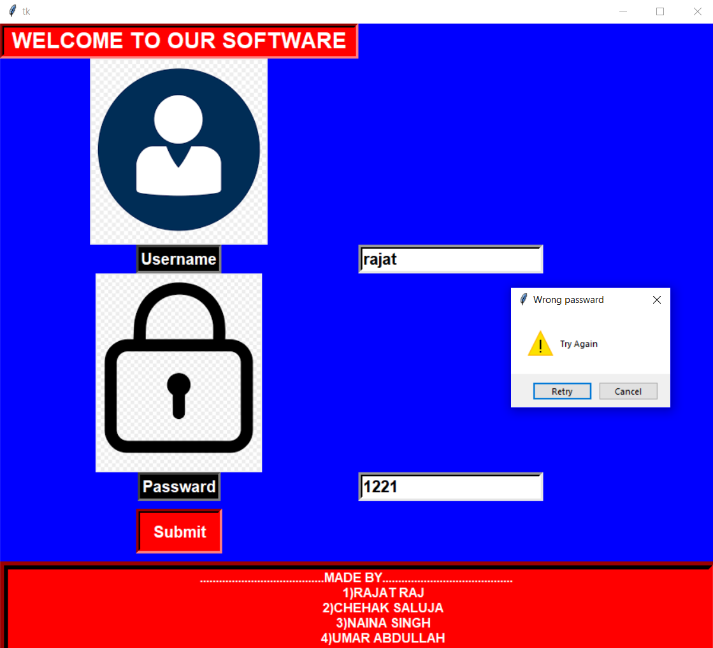

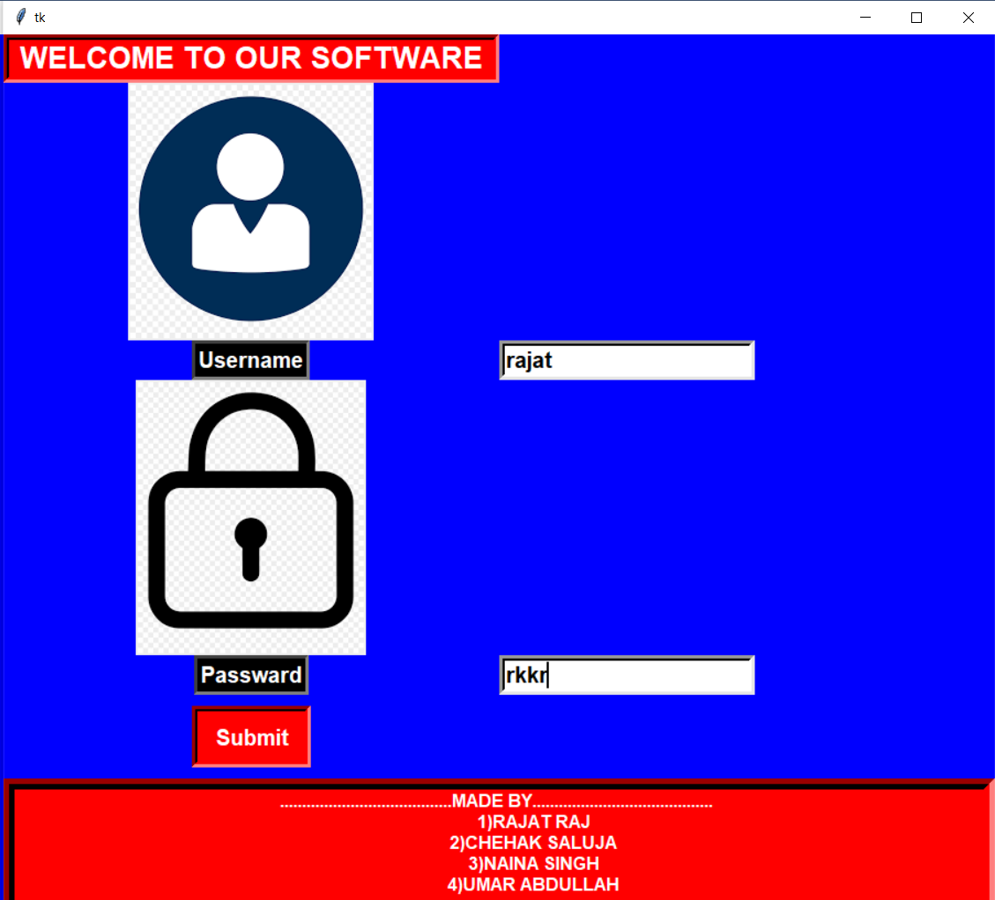

**Correct Passward**

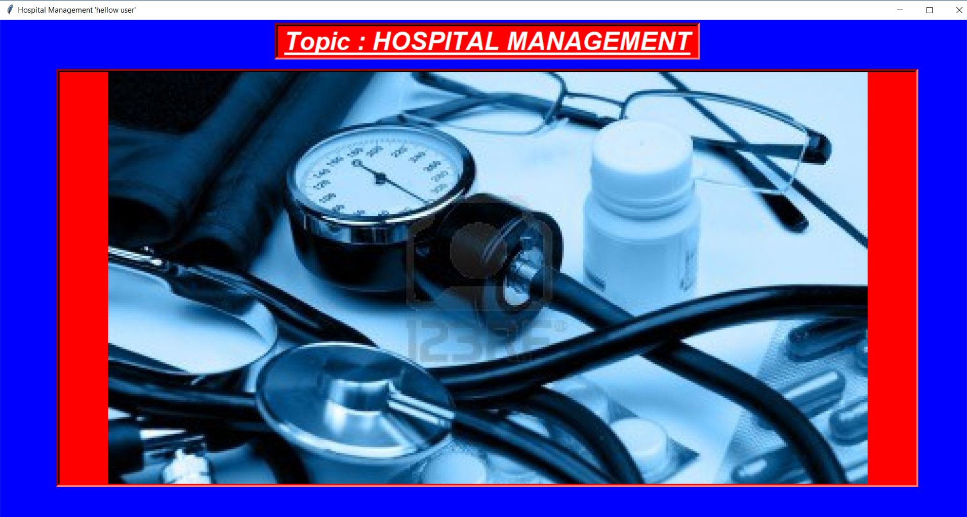

**CLICK ON THE IMAGE**

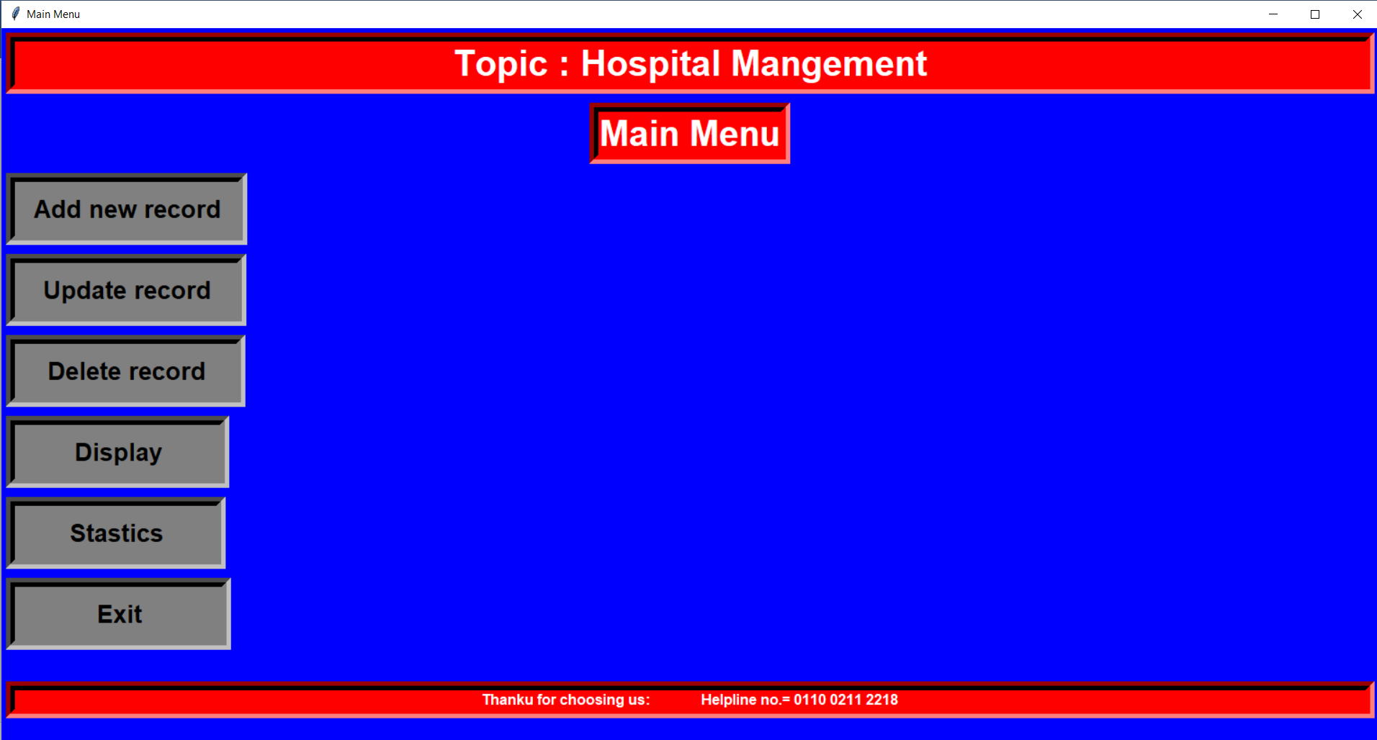

**Click on add new records**

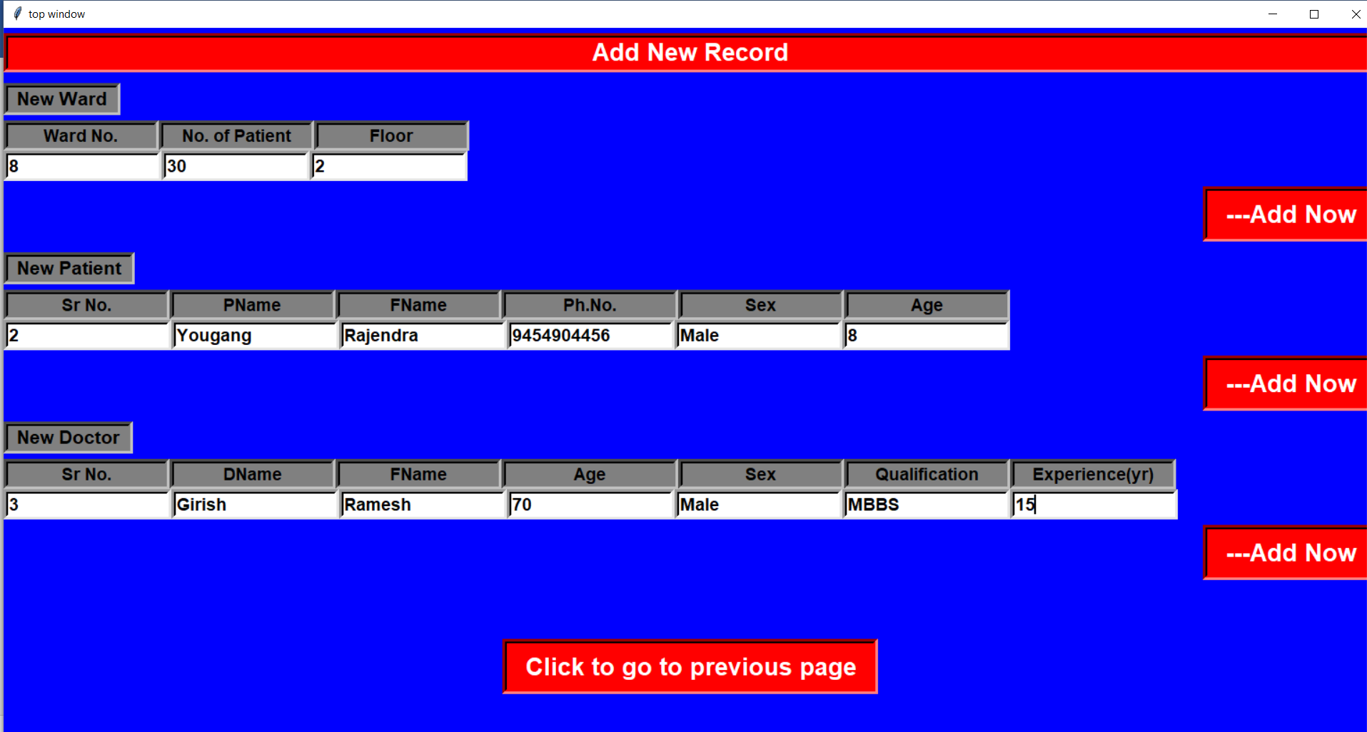

**Click on add now to add records**

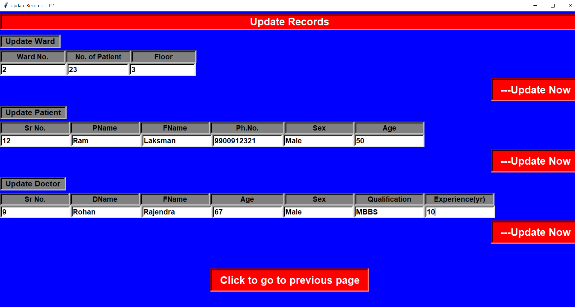

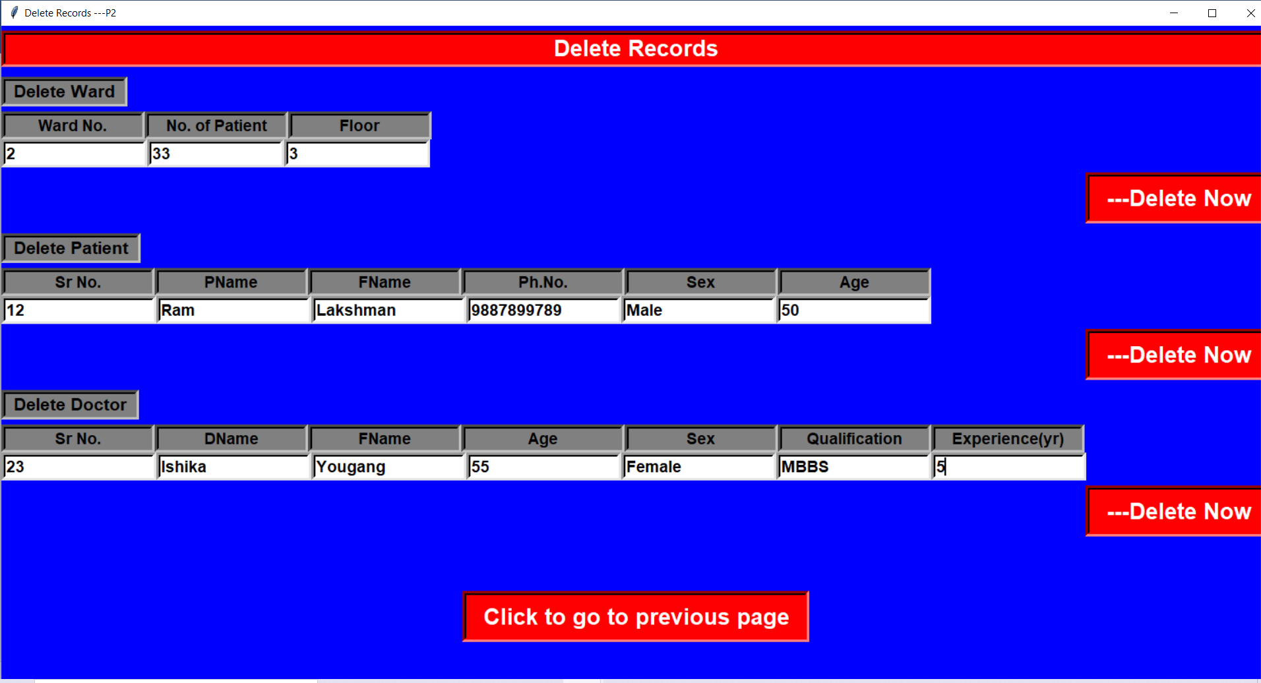

**Similarly update of delete records by clicking them**

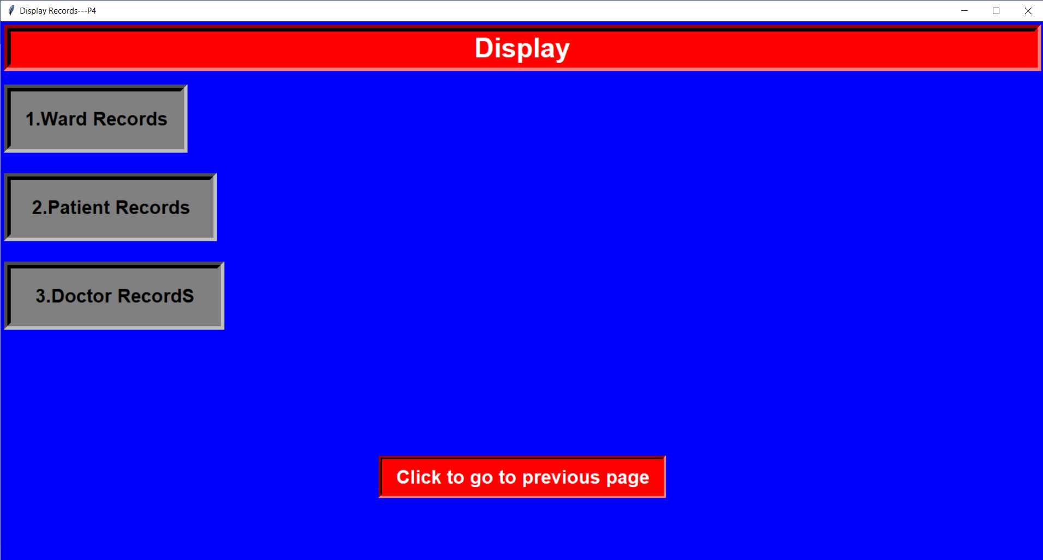

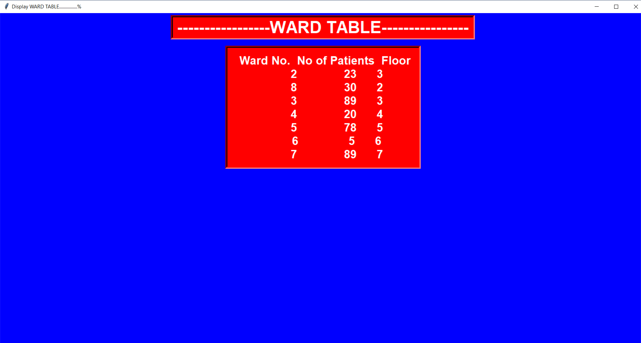

Click on display to see records and click the table which you want to see ,exit out of the table by clicking on it.

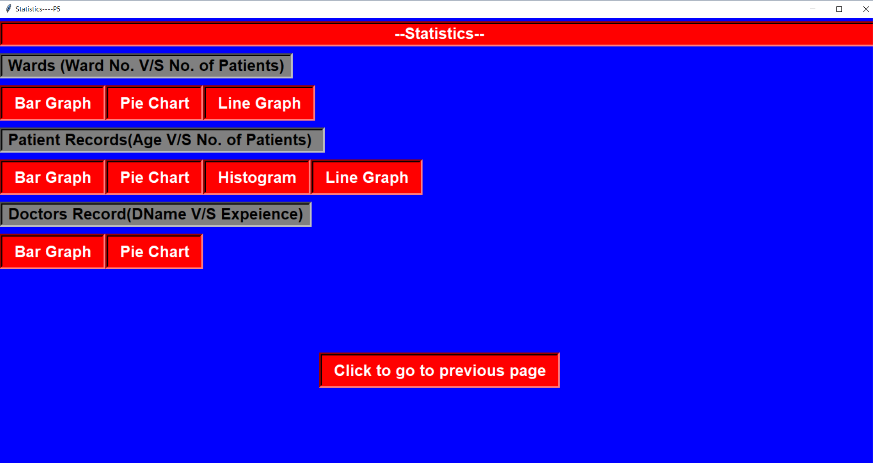

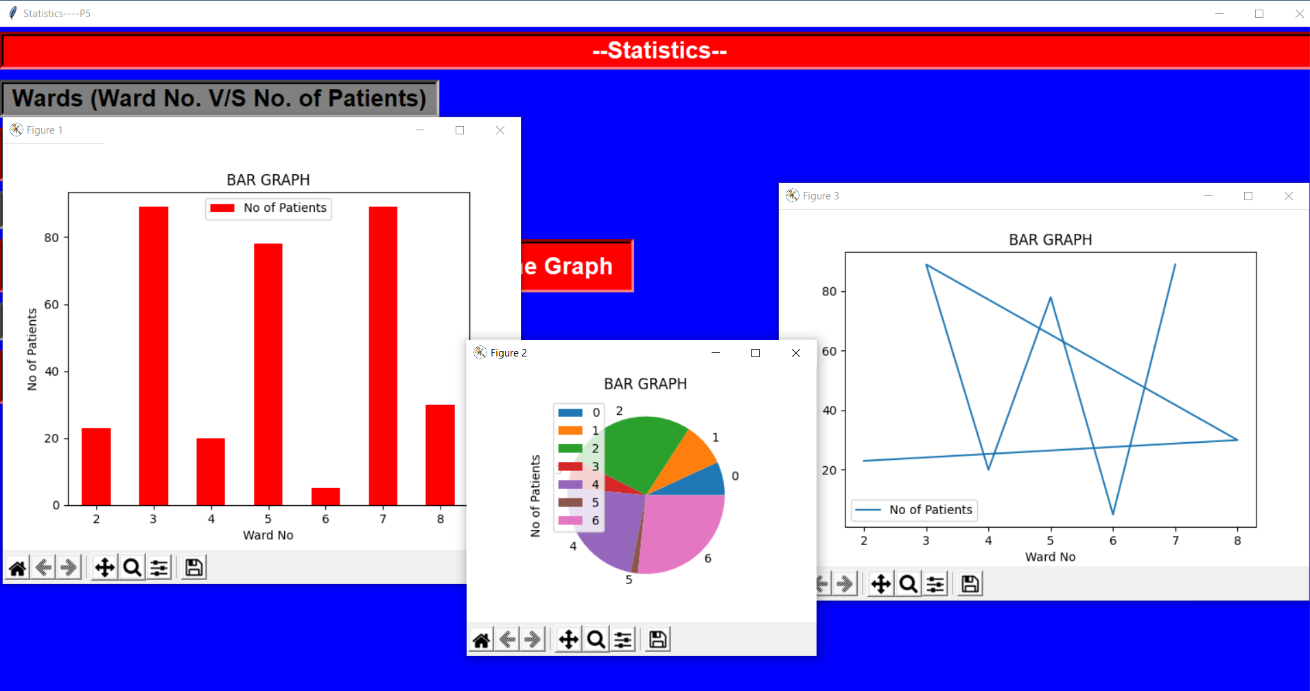



Click to Exit out

**Thank You**